PERSONAL DETAILS
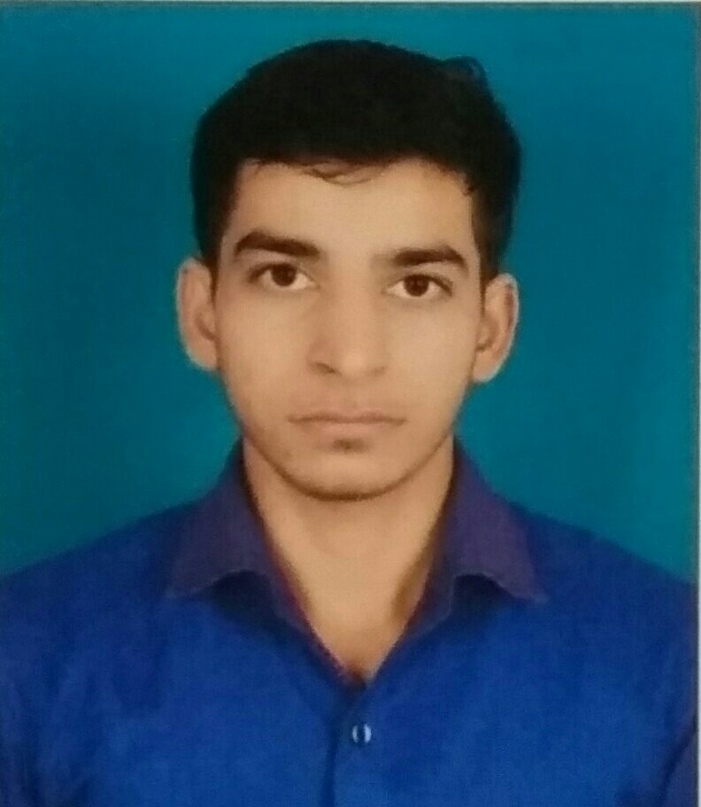

IRSHAD AGLODIYA
At-Nagel,Post-Moriya,Ta-Danta,
Di-Banaskantha 385120
Ph:+91-9913618736
Email:irshadaglodiya121@gmail.com
D.O.B.:23rd oct,1996
Nationality: Indian

Career Objective:

To associate myself with a professionally driven esteemed organization which offers continuous challenges and excellent growth prospects, where I could contribute significantly to the organization through my skills. Intend to build a career challenging and creative environment on logical ability progressive skills and result oriented approach.

FDUCATIONAL DETAIL:

Course | Name of The Institution | Board of Examination | Year of passing | CPI/Percentage
B.Tech(MECH) | Merchant Engineering College,Basna | Pondicherry University | 2017 | 7.23
H.S.C. | Exotica Junior Science College,Palanpur | Tamil Nadu Board | 2013 | 65%
S.S.C. | Shree P.G. Highschool,Moriya | Tamil Nadu Board | 2011 | 82%

AREA OF INTEREST:
- Engineering mechanics
- Cmposite materials.
- Quality management.
COMPUTER SKILLS:
- Operating system : Windows xp,Windows7
- Microsoft office 2003,2007
LANGUAGE SKILLS:

- Gujarati – (reading, speak and writing skills)
- Hindi - (reading, speak and writing skills)
- English - (reading, speak and writing skills)

PERSONAL COMPETENCIES

- Ability to work in a fast-paced environment to set deadlines
- Excellent oral and written correspondence with an exceptional attention to detail
- Highly organised with a creative flair for project work
- Enthusiastic self-starter who contributes well to the team

INTERESTS AND ACTIVITIES

DECLARATION:
I hereby declare that all the statements made above are true to the best of my knowledge.

Date:01/02/2017
Place:Mehsana, Gujarat Irshad Aglodiya

